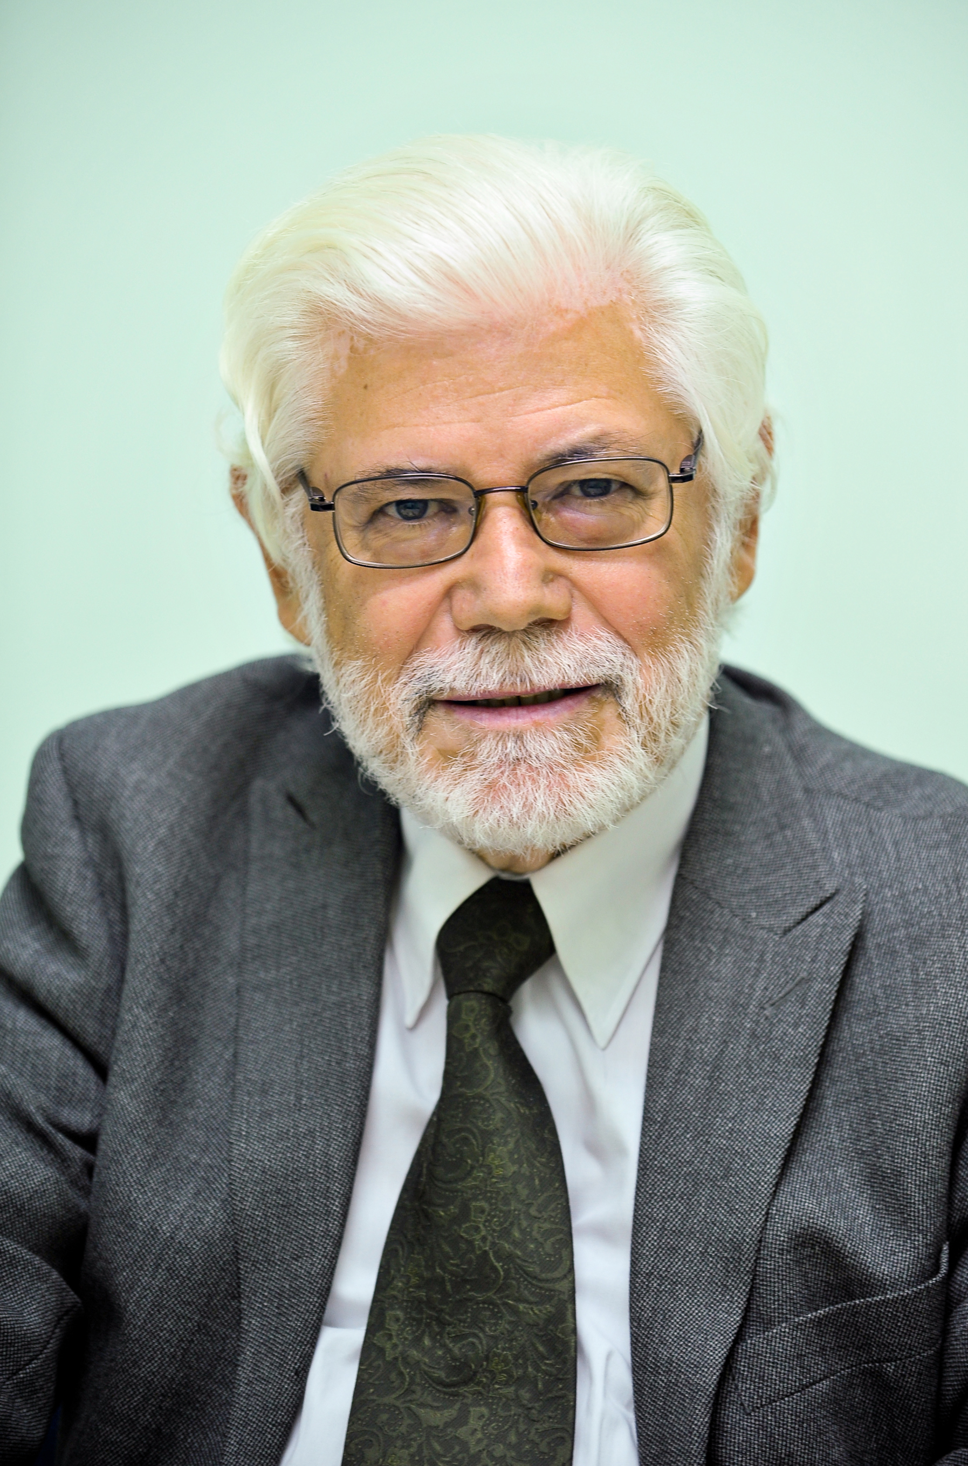
Brief Biosketch of Athanasios P Covanis, M.D

Dr Athanasios P Covanis was born in the county of Viotia in Greece, where he was initially raised and completed his primary school education. Further school education was continued in Athens, which subsequently lead to the Medical School at the University of Athens. After his graduation, he completed two years Military Service as a Medical officer in the Artillery Unit. Then he moved to United Kingdom where he did his postgraduate studies in Peadiatrics, Neonatology, Child Neurology, Neurophysiology, Adult Neurology and Epilepsy. He worked mainly in Birmingham Hospitals and at University of Aston as an Honorary Research Fellow, Edinburgh Children Hospital and Leeds General Infirmary. He became interesting in Epilepsy the last four years in UK during which time he spend three years with Professor Peter Jeavons. He returned to Athens in the end of 1980’s. After returning in Athens he worked for two years in a Child Psychiatric Hospital as a Child Neurologist. Subsequently he moved to the Neurology/ Neurophysiology Department at the Children’s Hospital “Agia Sophia” where he was appointed the Head of the Department in March of 1987 and continues to date.

Dr Covanis has obtained the following Diplomas: Diploma in Child Health from the University of Glasgow, Diploma in Peadiatrics from Athens University, Diploma in Adult Neurology from Athens University. In 1982 he completed his MD thesis, which he passed with distinction from Athens University. He has also obtained the certificate of Epileptologists and the Certificate “Train the Trainers” from the European Epilepsy Academy (EUREPA). He has maintained an active clinical interest in epilepsy, particularly interest in classification and epilepsy syndromes in infancy and childhood.
Dr Covanis is an Ambassador for Epilepsy, President of the Greek League and President of the Greek Bureau for Epilepsy, Vice Chair for Europe of the International Bureau for Epilepsy[IBE], Chair of the European Regional Executive Committee, Member of Joint Executive Committee of the International Bureau and League for Epilepsy [IBE/ILAE], Member of the Management Group and Political Action Group- FONDE- of the European Concerted Action and Research in Epilepsy (EUCARE), Honorary Member of the Yugoslav Union of Leagues Against Epilepsy (YULAE) and member of the European Epilepsy Academy (EUREPA). He had also been until recently Vice –President of IBE (2001-2005) and Member of the Executive Committee of the Hellenic Neurology Society.
Dr Covanis is Member of the Editorial Board of Epilepsia, Member of the Editorial Board of Epileptic Disorders, Member of the Editorial Board of the International Epilepsy News.
Among many activities Dr Covanis has organized the 7th European Epilepsy and Society Conference in Athens in 2000, the 7th Mediterranean Epilepsy Conference in 2001, the International Epilepsy and Co-Morbidity Conference in Athens in 2003, four Pan- Hellenic International Epilepsy Conferences, five workshops in Epilepsy and now is in the process of organizing the 5th Pan- Hellenic Epilepsy Conference in October 2009, and also the 9th European Epilepsy Congress 2010 in Rhodes.
He has contributed as author (co- author) of several articles in different journals and chapters of books.

